The title of your work should be here, in 14pt bold font (MAX 25 WORDS)

F. A. Author¹, S. A. Author², E. E. Author² (12pt font)
¹Neurophysics Group, IFGW, UNICAMP, ²Genetics Dept., FCM, UNICAMP, ³CTI Renato Archer (10pt font)

Introduction: This study…
X
X
X
X
X

Materials and Methods: All images were acquired in a 3T scanner (Philips Achieva)…
X
X
X

Results: We found that…
X
X
X

Discussion/Conclusion: in conclusion…..
X
X
X
X
X

Figure/Table/Graph:

Legend: ……..
A | B
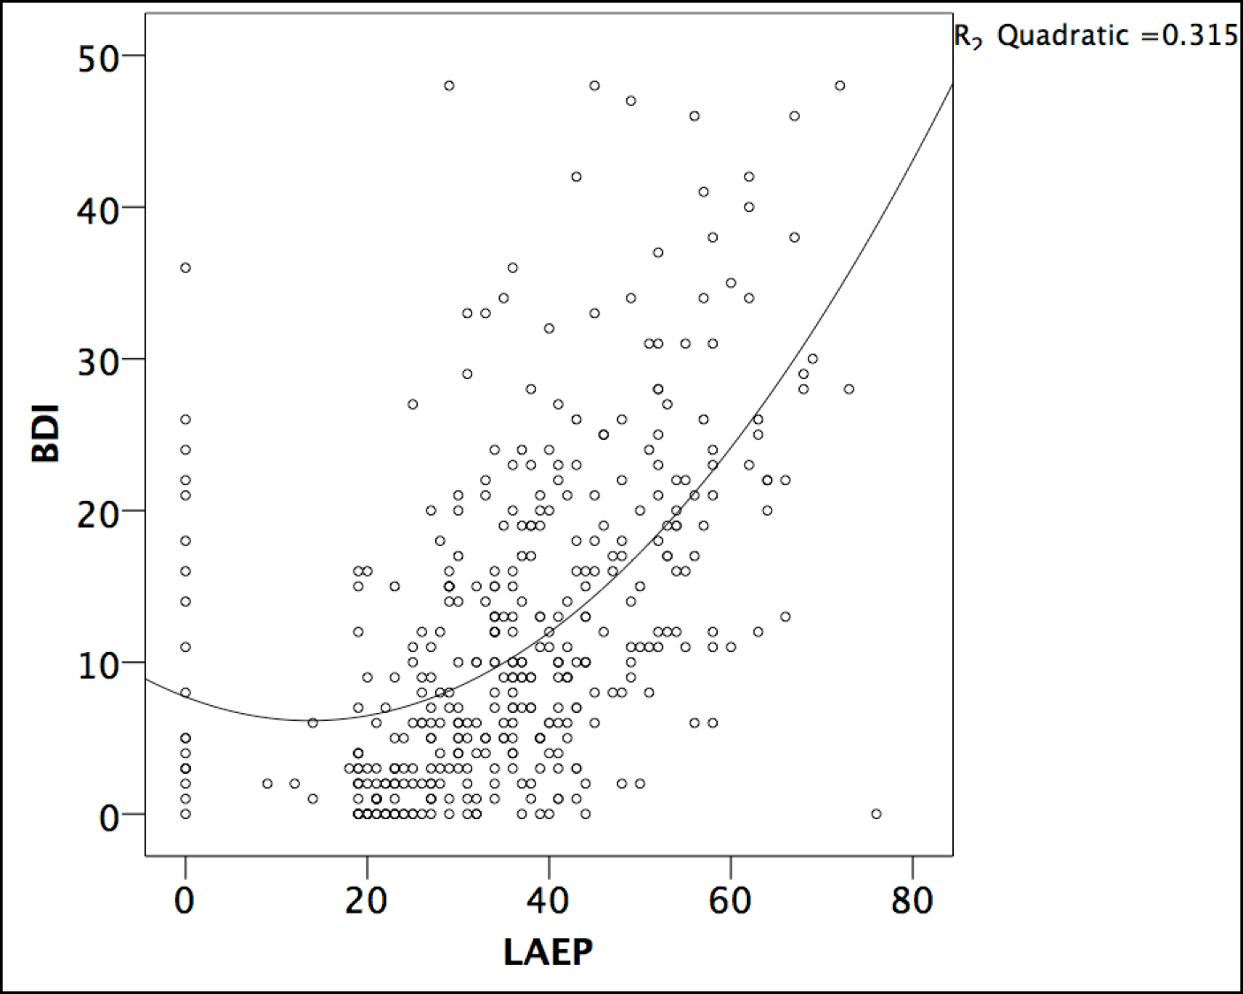 | 